RESOURCE DIRECTORY

Gratitude CHALLENGE
for More Abundance
and Clarity

Brought to you by the…
Creating clarity and increasing gratitude require not just self-awareness, but action on our parts. Fortunately, there are many tools available to help us in our quest to explore and expand our consciousness, reaching into the deep wells of self-knowledge.
Here are twenty-one resources to consider.
- Start Where You Are: A Journal for Self-Exploration
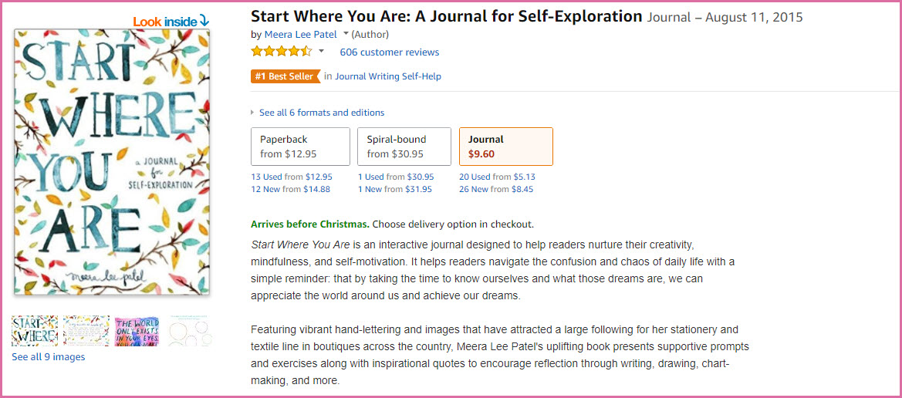
Don’t let the simplicity of this colorful, fun journaling workbook fool you. It is beautifully set up to help you uncover and record your goals and motivations, while keeping you mindfully on track.
PRICE: $12.05 USD (Paperback); $30.95 USD (Spiral-bound)
- Gratitude Journal
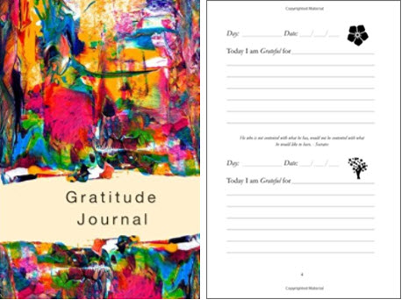
This simple little paperback journal allows you to record five things you are grateful for every day. You can date your entries (dating is flexible, so you can start recording at any date you please).
PRICE: $6.49 USD (Paperback)
- 52 Lists for Happiness
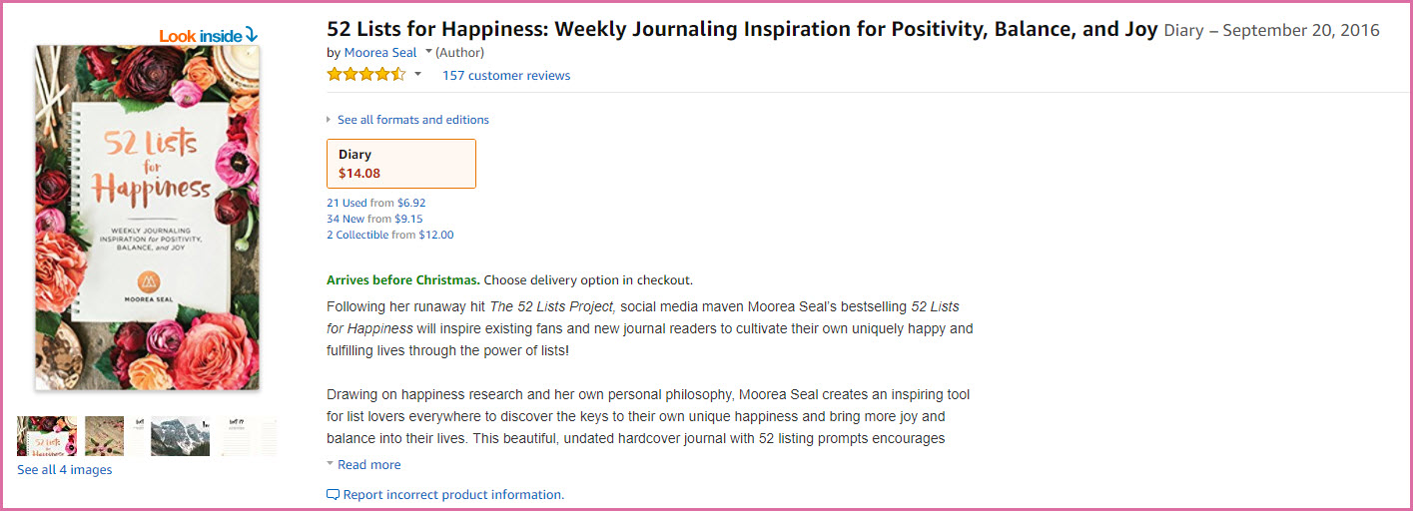
If you are a died-in-the-wool list-maker, then this beautifully-thought-out-and-designed workbook is for you. It helps you formulate a thorough selection of lists, one per day; then provides action tips for you to transform these lists into steps toward your goal.
Containing many extras in the form of illustrations, beautiful photography, copper foil and even a red velvet ribbon, “52 Lists for Happiness” also makes the perfect gift. Not only is it a useful workbook, but a visual feast for the eyes.
PRICE: $14.08 USD (Hardcover)
- Gratitude Journal
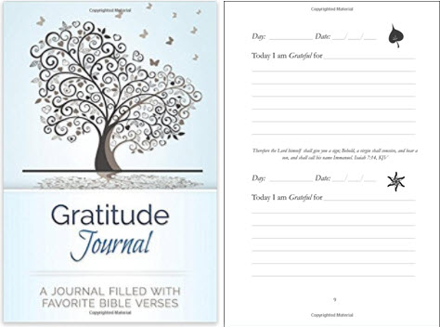
This 5-star, simple journal allows you to quickly write down and record 3-5 things per day that you feel grateful for. Included bible verses enrich this best-selling journal further, for those of the Christian faith or who simply like to receive inspiration while recording.
PRICE: $4.09 USD (format unspecified)
- The Artist’s Way: A Spiritual Path to Higher Creativity
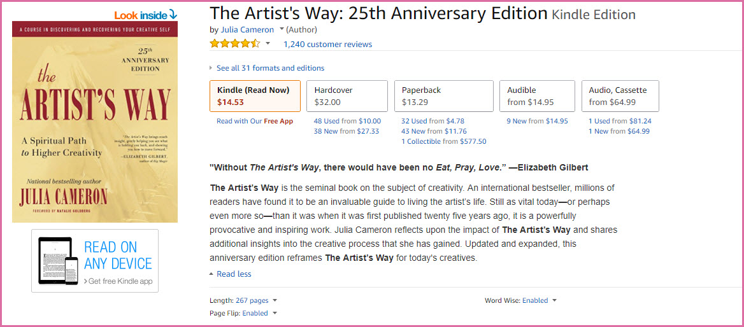
This one is not a journal: It is a deeply-thought-ought book about re-igniting your creativity, considered by many to be a classic and the ultimate guide to living authentically and re-filling your well of inspiration.
It is the book that inspired author Elizabeth Gilbert to write “Eat, Pray, Love”.
PRICE: $14.35 USD
- Little Book of Mindfulness
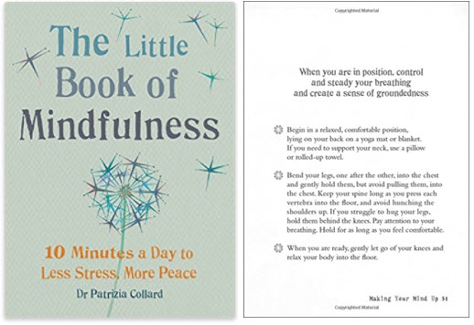
This inspirational workbook includes rich tips on the practical application of mindfulness and meditation techniques; tips on breathing, posture, health—as well as daily doses of inspiration. All of which can be put into practice within 5 or 10 minutes per day.
PRICE: $4.02 USD (Kindle); $7.07 USD (Flexibound)
- Conquering Writers Block and Summoning Inspiration: Learn to Nurture a Lifestyle of Creativity
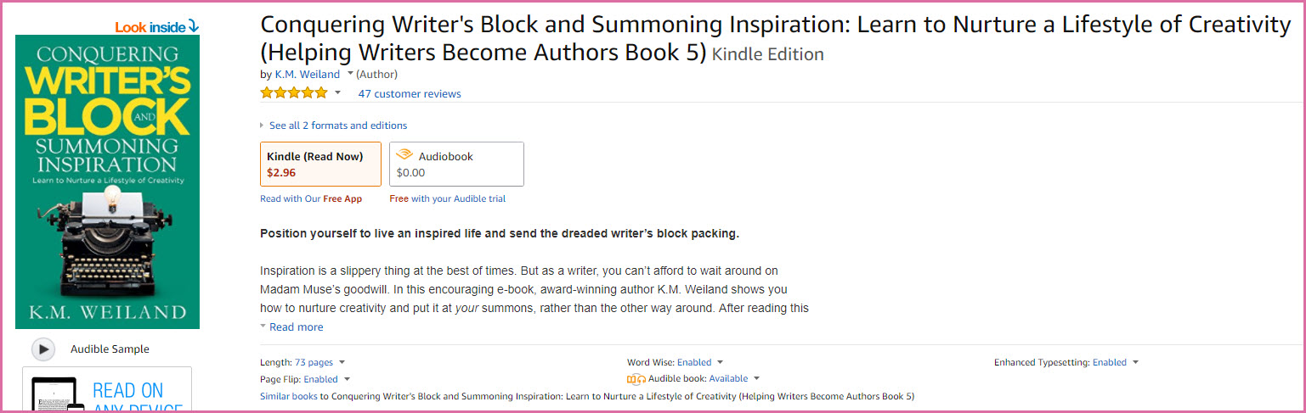
Although this book is primarily meant for those who write, it is far more than that. It is a joyous book that reflects author K. M. Weiland’s deep Christian faith, re-igniting wonder in the reader even as it helps you dispel your own personal blocks to creativity.
PRICE: $2.96 USD (Kindle); FREE Audio version available with
- Audible
Listen to your favorite inspirational books for free by installing Amazon-compatible Audible.
PRICE: Plans start at $14.95 USD per month: Free trial
- Stop Breathe Think
This customized, guided meditation app has been cited by countless people as the only app that works on chronic insomnia. Stop Breathe Think prompts you to answer questions on your emotional state, so it can “diagnose” and present a customized meditation for you, as well as yoga or acupressure points to apply. Winner of the 2017 Webby “People’s Voice Award for Best Health App”.
PRICE: Available for both iPhone and Android
- Sleep Cycle
This intelligent app allows your mobile to analyze your sleep patterns and wake you during your lightest sleep phase for maximum refreshment. A godsend, if you habitually wake up groggy and out of sorts (a common problem when you awake during your deepest sleep phase instead).
PRICE: Free; Available for both iPhone and Android
- Calm
This popular mindfulness and meditation app contains a unique feature—Sleep Stories. If you always fall asleep when listening to stories, this feature can help you tame chronic insomnia.
Provides nature scenes, meditations and breathing exercises too.
PRICE: Plans start at $4.99 USD per month, billed annually
- Gratitude 365
This five-star iPhone app makes journaling easy. Choose a photo for the day, view them as a calendar, list what you are grateful for, total up your daily gratitudes, password-protect your journal—and more. If manually writing in a hard copy is not your thing and you live digitally, this may be the gratitude journal for you.
PRICE: Free from the App Store
- Gratitude Reminders for Optimism and Happiness
Rather than just allowing you to journal, this app serves up random gratitude reminders during the day, along with a beautiful photographic background. You can make your own specific gratitude reminders, choose a mantra, upload your own photos if you prefer and set how many times per day you receive a reminder.
PRICE: Free from the App Store
- DoYogaWithMe.com
If you are a visual learner, try the hundreds of free, streaming videos from this positive online community.
PRICE: Free, but you can also donate or subscribe for $10.00 USD per month.
- Pranayama Breathing Videos
A good place to start, when you are considering learning yoga or exploring DoYogaWithMe.com, is with this selection of Pranayama breathing videos. (‘Pranayama’ is your basic yoga breathing techniques, the foundation of yoga.)
PRICE: Free.
- Yoga for Chronic Stress, Anxiety and Depression
Three-part video course that helps you take an honest look at the causes of your own unique stressor and dissipate much of that stress through yoga, while elevating your mood at the same time, presented in written and video form—with access to a forum, so you can ask questions.
PRICE: Free.
- The Real Meaning of Meditation
Excellent, no-nonsense article from Yoga International explaining all the basics of meditation—including how to do it, how to cultivate stillness, signs of progress, what you can expect and the principles behind it.
Well worth reading, if you’re new to meditation.
- FEIVO Women’s Control Workout
You can wear any type of loose-fitting pant for yoga, but if you need a little more control and like your exercise clothes to feel as if they are not even there, Feivo exercise pants are well worth checking out. These ultra-comfortable yet flattering exercise pants also work well for yoga. Hidden waistband pocket for keys or cash. Moisture-wicking polyester/spandex; interlocking chafe-free seams.
Select from a wide variety of styles and colors.
PRICE: $9.99-$15.99 USD
- Racerback Tank Tops
The perfect complement to your Feivo leggings. 95% Rayon, open back that can be left open or tied.
Select from a wide variety of styles and colors.
PRICE: $6.99-$21.99 USD
- Marswall Extra-Thick Yoga Mat
This is a great, basic, non-slip yoga mat in non-toxic, Phalate-free, PVC-free and LATEX-FREE mat—perfect for those with Latex allergies. And perfect if you’re just trying out yoga and are not yet sure you want to invest in pricier products. (Also, great for gym stretches, too.)
Select from five colors (blue, green, black, pink and purple).
PRICE: $15.98 USD
- Liforme Yoga Mat
This is the crème-de-la-crème of yoga mats, with guide marks on its eco-friendly, comfortable surface. It is also thicker and more pleasant to come in contact with than most mats and comes with its own Yoga Mat bag.
Select from four colors (blue, green, black, pink).
PRICE: $149.95 USD.
Part of experiencing gratitude that is often neglected: Being grateful for yourself, just the way you are; for all the things you are trying in order to contribute more to the world and to those around you; for your willingness to grow and embrace honestly. Choose aids and accessories that add to your feeling of nurture and support vital self-care.
Select the products and resources that make you feel relaxed, stress-free and beautiful, so you can also be grateful for the miracle that is you.

